Methodology paper
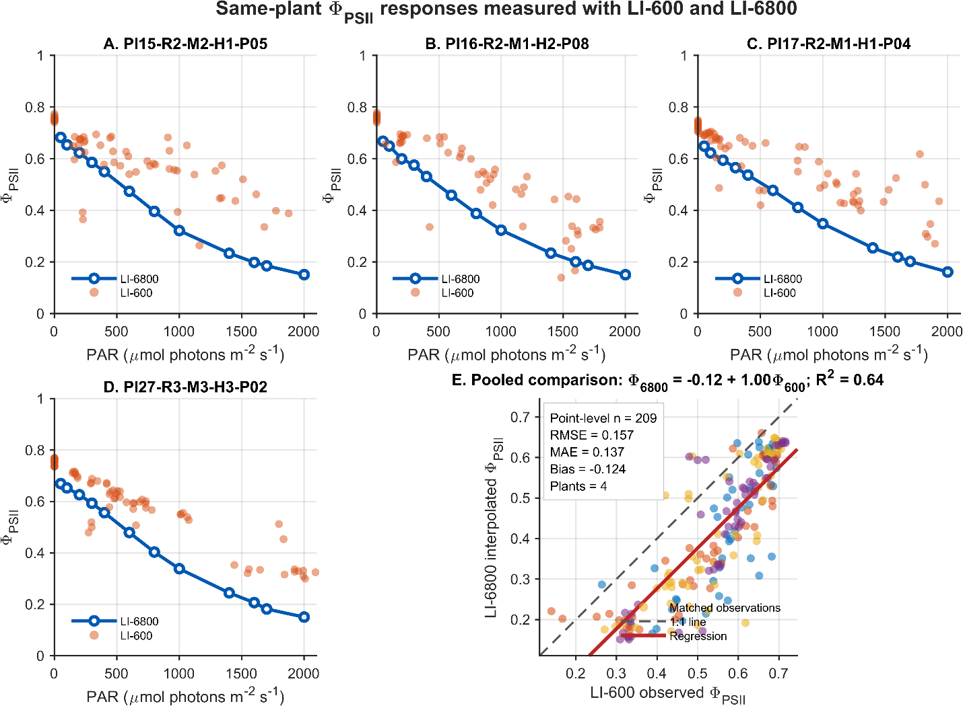
Figure. Same-plant effective quantum yield of photosystem II responses measured with the LI-6800 and LI-600. Panels A–D show-controlled LI-6800 $Φ_{PSII}$light-response curves and repeated LI-600 field observations for four matched maize plants measured at the blister stage. Blue lines and open circles represent LI-6800 measurements obtained across controlled chamber PAR levels, whereas orange points represent LI-600 observations collected under ambient field irradiance. Panel E shows the pooled relationship between LI-600 observed $Φ_{PSII}$and LI-6800 $Φ_{PSII}$interpolated at corresponding LI-600 PAR values. The dashed line represents the 1:1 relationship and the solid line represent the fitted regression. The pooled relationship was $Φ_{6800}=-0.121+0.995Φ_{600}$, with $R^{2}=0.639$, RMSE $=0.157$, MAE $=0.137$, and bias $=-0.124$, based on 209 point-level comparisons from four plants. The pooled records represent repeated observations nested within plants and should not be interpreted as independent biological replicates.

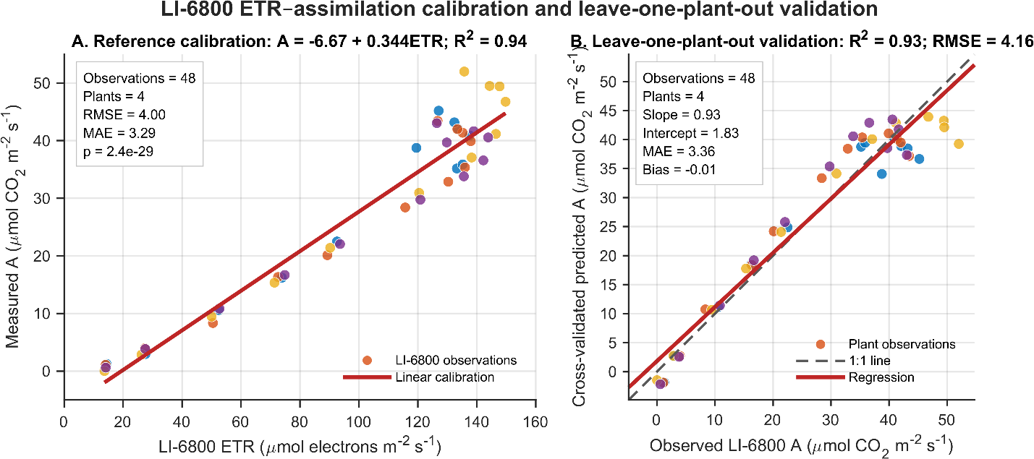
Figure LI-6800 reference calibration linking electron transport rate to net CO₂ assimilation. Panel A shows the empirical relationship between LI-6800 electron transport rate and directly measured net assimilation across 48 observations from four blister-stage maize plants. Points are colored by plant, and the solid line represents the fitted linear regression, $A=-6.672+0.3436ETR$. The calibration explained 93.8% of the variation in assimilation, with RMSE $=4.004$and MAE $=3.293 μ{\text{mol CO}}_{2}{\text{ m}}^{-2}{\text{ s}}^{-1}$. Panel B shows leave-one-plant-out cross-validation, in which the calibration was fitted using three plants and tested on the excluded fourth plant. The dashed line represents the 1:1 relationship and the solid line represents the observed-versus-predicted regression. Cross-validation produced $R^{2}=0.933$, RMSE $=4.162$, MAE $=3.361$, bias $=-0.011$, slope $=0.933$, and intercept $=1.826$.

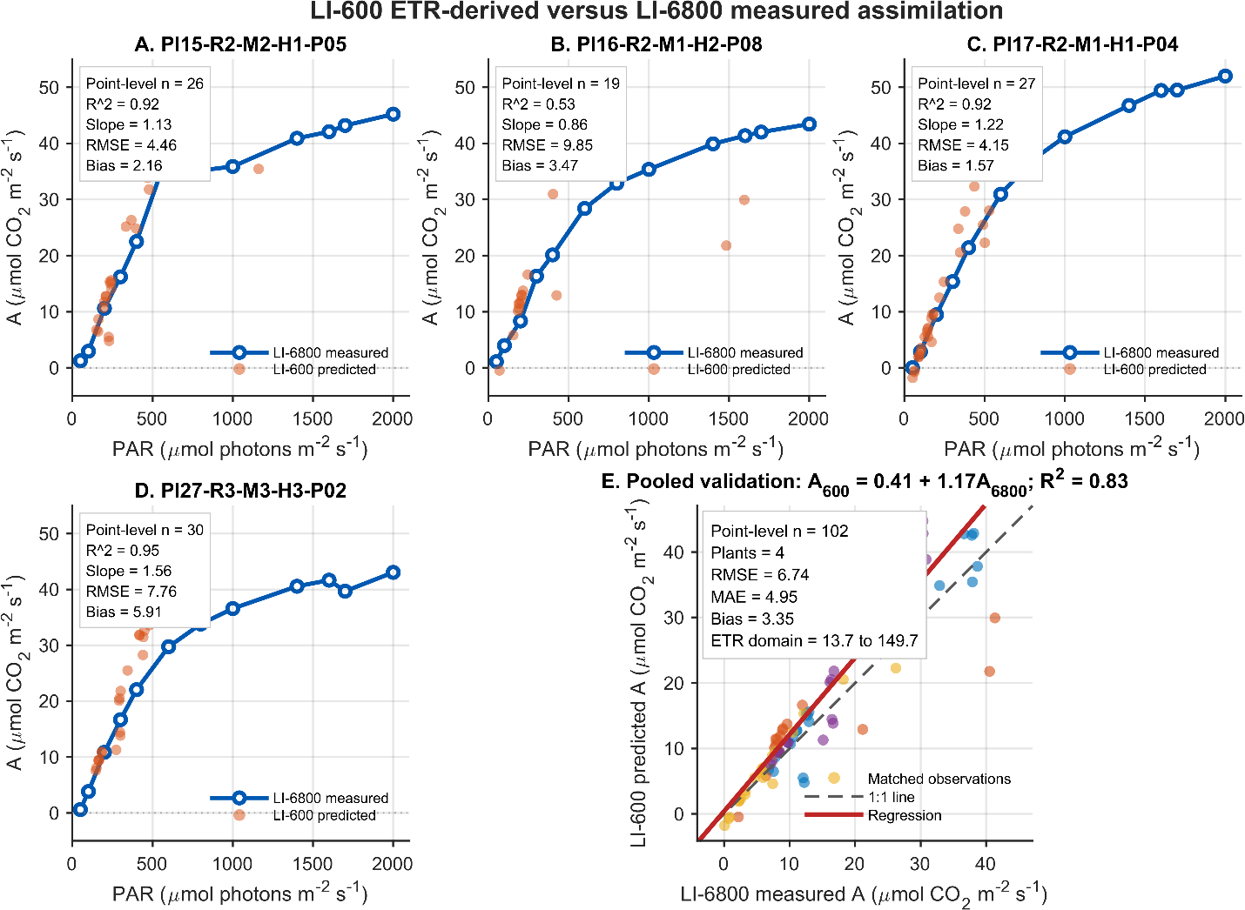

Figure LI-600 ETR-derived assimilation estimates relative to LI-6800 measured light-response curves. Panels A–D compare directly measured LI-6800 net assimilation with LI-600 assimilation predicted from the LI-6800 ETR–assimilation calibration for four matched maize plants. Blue lines and open circles represent LI-6800 measured assimilation across controlled PAR levels, while orange points represent LI-600 ETR-derived assimilation estimates at ambient PAR. Predictions were restricted to the LI-6800 ETR calibration range of 13.666–149.725 $μ{\text{mol electrons m}}^{-2}{\text{ s}}^{-1}$and to the measured LI-6800 PAR range for each plant. Panel E shows the pooled relationship between LI-600 predicted assimilation and LI-6800 measured assimilation interpolated at corresponding PAR values. The dashed line represents the 1:1 relationship and the solid line represents the fitted regression. The pooled equation was $A_{600,predicted}=0.407+1.174A_{6800,measured}$, with $R^{2}=0.831$, RMSE $=6.738$, MAE $=4.949$, and bias $=3.348 μ{\text{mol CO}}_{2}{\text{ m}}^{-2}{\text{ s}}^{-1}$, based on 102 point-level comparisons. The positive bias and slope greater than 1 indicate systematic overprediction by the LI-600-derived estimates.

Same-plant LI-600 and LI-6800 reference-calibration framework
A same-plant reference-calibration approach was used to evaluate whether high-frequency LI-600 fluorescence measurements could be related to LI-6800 gas-exchange light-response measurements. Four maize plants measured at the blister stage were selected because both LI-600 and LI-6800 observations were available for the same plant and calendar date. Plant identity was matched using the complete field barcode containing plot, replication, moisture zone, hybrid, and plant number.
The matched plant-date combinations were Pl15-R2-M2-H1-P05 on 21 July 2026, Pl16-R2-M1-H2-P08 on 21 July 2026, Pl17-R2-M1-H1-P04 on 20 July 2026, and Pl27-R3-M3-H3-P02 on 22 July 2026.
LI-600 data extraction and quality control
LI-600 observations were obtained from the plant-day dataset containing repeated measurements for plants with at least 30 observations per day. Records were filtered by exact plant barcode and calendar date. The variables retained were ambient photosynthetically active radiation, effective quantum yield of photosystem II, and electron transport rate, corresponding to SENSOR_Qamb, FLUORO_PhiPS2, and FLUORO_ETR, respectively.
Records were retained only when PAR, $Φ_{PSII}$, and ETR were finite and within predefined physiological limits. PAR was restricted to 0–3000 $μ{\text{mol photons m}}^{-2}{\text{ s}}^{-1}$, $Φ_{PSII}$to 0–1, and ETR to non-negative values. After quality control, 61, 61, 61, 74, and 72 LI-600 observations were retained for Pl15, Pl16, Pl17, and Pl27, respectively.
LI-6800 light-response data
For each matched plant, the corresponding worksheet was extracted from the LI-6800 blister-stage workbook. Because LI-6800 files use a two-level header structure, grouped and variable headers were combined to identify incident chamber PAR, effective PSII quantum yield, electron transport rate, and net CO₂ assimilation. The variables used were LeafQ_Qin, FLR_PhiPS2, FLR_ETR, and GasEx_A.
LI-6800 observations were retained when PAR, $Φ_{PSII}$, ETR, and assimilation were finite; PAR was within 0–3000 $μ{\text{mol photons m}}^{-2}{\text{ s}}^{-1}$; $Φ_{PSII}$was within 0–1; and ETR was non-negative. Measurements were sorted by PAR, and duplicate PAR levels were removed. Each plant contributed 12 valid LI-6800 light-response observations, resulting in 48 total calibration observations.
Comparison of $Φ_{PSII}$responses
LI-600 field observations and LI-6800 controlled light-response measurements were compared at the level of $Φ_{PSII}$. For each plant, the LI-6800 $Φ_{PSII}$response was linearly interpolated to the PAR values recorded by the LI-600. Comparisons were restricted to LI-600 PAR values falling within the measured LI-6800 PAR range for the same plant.
Plant-level and pooled relationships were evaluated using ordinary least-squares regression. Agreement was summarized using the regression slope and intercept, coefficient of determination, root mean square error, mean absolute error, and mean bias. Bias was calculated as the interpolated LI-6800 value minus the LI-600 observation.
Because repeated LI-600 measurements were obtained from the same plants, point-level comparisons were treated as repeated observations nested within four plant-level experimental units rather than as independent biological replicates.
LI-6800 ETR–assimilation calibration
An empirical linear model was developed using LI-6800 observations to relate directly measured net CO₂ assimilation to LI-6800 electron transport rate:
$$A=β_{0}+β_{1}ETR$$
where $A$was net assimilation and ETR was the LI-6800 electron transport rate. The calibration was fitted using all 48 LI-6800 observations from the four plants.
Model performance was summarized using $R^{2}$, RMSE, MAE, mean bias, and the overall model significance test. This calibration was treated as a reference relationship within the sampled plants, growth stage, and environmental conditions.
Leave-one-plant-out cross-validation
Model transferability among plants was evaluated using leave-one-plant-out cross-validation. In each iteration, all observations from one plant were excluded, the ETR–assimilation model was fitted using the remaining three plants, and assimilation was predicted for the excluded plant.
Cross-validation performance was summarized using $R^{2}$, RMSE, MAE, mean bias, slope, and intercept of the observed-versus-predicted relationship. This procedure preserved plant-level independence during validation and avoided random splitting of repeated observations from the same plant across training and testing datasets.
Prediction of LI-600 assimilation
The final LI-6800 ETR–assimilation calibration was applied to LI-600 ETR measurements to generate model-based assimilation estimates. These values were interpreted as predicted assimilation and not as direct gas-exchange measurements.
To avoid unsupported extrapolation, LI-600 predictions were restricted to observations with ETR values within the measured LI-6800 calibration range. Predictions were also limited to LI-600 PAR values within the corresponding plant’s LI-6800 light-response range.
For each valid LI-600 observation, LI-6800 measured assimilation at the corresponding PAR was estimated by linear interpolation of the plant-specific LI-6800 A–PAR response. LI-600 predicted assimilation was then compared with the interpolated LI-6800 measured assimilation.
Plant-level and pooled comparisons were evaluated using ordinary least-squares regression and summarized using slope, intercept, $R^{2}$, RMSE, MAE, and mean bias. The pooled analysis was interpreted as a point-level agreement assessment based on repeated observations nested within four plants, not as validation based on independent biological replication.
Statistical analysis
All data processing, interpolation, regression, cross-validation, and figure generation were conducted in MATLAB. Ordinary least-squares models were fitted using fitlm. Prediction error was quantified as the predicted value minus the reference value. RMSE described overall prediction error, MAE described average absolute error, and bias described systematic over- or underprediction.
The workflow was interpreted as an internal same-plant reference calibration and screening framework. LI-600-derived assimilation estimates were not considered direct substitutes for LI-6800 gas-exchange measurements.

Potential Submission Plan
Reference Paper: Bunce JA. Photosynthetic acclimation to temperature is affected by night temperature in Zea mays. Photosynthetica. 2024 Feb 6;62(1):112-115.
doi: 10.32615/ps.2024.008. PMID: 39650637; PMCID: PMC11609766.

Note: This draft was prepared with the assistance of ChatGPT for manuscript organization and language refinement. The final manuscript will be independently revised and finalized after confirming the scientific methodology, statistical analyses, and interpretation of the results.

